Skills Matrix solution overview

Skills Matrix solution overview 1
Features 2
Workflow 2
Define department 2
Define skill 2
Define job description (JD) 3
Define employee 3
User Manual 4
Manage Skills 4
Adding new skill 4
Editing existing skill 4
Deleting skill 4
Manage departments 5
Adding new department 5
Editing department 5
Deleting department 5
Manage JDs 5
Adding new JD 6
Editing JD 6
Deleting JD 6
Manage Staff 7
Adding new employee 7
Editing an employee 7
Deleting an employee 8
Support information 8

Features
- Stores skills, their classification, extent and any certification that is associated with a skill
- Stores information about job positions (job description also referred as JD) in terms of mandatory skills. Several skills can be attached to a JD and each skill may carry different weight depending skill relevance in particular role.
- Skills are shared between JDs meaning if employee moves to different job the skill will be carried over with employee and will constitute core or additional skill in new role depending on new role skill requirement
- Same skill can be associated with multiple JDs
- Stores information about departments/teams and job positions within them
- Several JDs can be associated with a department
- Stores information about employee, their job placement, job core skills (required for that position) and any additional skills employee might have
- For each employee every skill stores a confidence factor between 0-100% enabling to establish training requirements

Workflow

Define department
Prerequisites
- None

Required information
- Department/team name

Notes
Use short department/team name when possible. For example use “NMC Tx” instead of “Network Management Centre Transmission”. The department is displayed in several list boxes as one of multiple columns of limited size. Long names will not be visible and might lead to incorrect definition of jobs and/or skills

Define skill
Prerequisites
- None

Required information
- Skill name
- Skill extent (use one of the predefined extent values or provide your own)
- Skill group classification (use one of the predefined values: business, hardware, softskill, software)

Notes
Use short skill name when possible. The slill is displayed in several list boxes and tree views as one of multiple columns of limited size. Long names will not be visible and might lead to incorrect data being used.

Define job description (JD)

Prerequisites
- Department has been defined
- Skills that will be associated with position have been defined

Required information
- Job title
- Department (use one of defined jobs)
- Skills (checkmark relevant skills form defined earlier skill pool)
- Skills’ weight (assign value between 1 and 10 indicating how important the skill is in this position. The higher the value the more important particular skill is.

Notes
Use as short job title name as possible as it will be used in limited length columns in several list-boxes and tree-views.

Define employee

Prerequisites
- Job position defined

Required information
- Employee name (unique employee name)
- Department (select from defined earlier departments)
- Job Position (checkmark position(s) employee holds)
- Core skills (these will be automatically added to the user profile as compulsory skills)
- Additional skills (add additional skills. Confidence for additional skills must be set to value greater than 0)

Notes
Additional skills must have confidence set to value greater than 0 otherwise they will not be saved with employee profile. If employee is reassigned to other job then any skills that are not mandatory in new role and have confidence greater than 0 will be retained in employee profile as additional skills.

Define department -> Define skills -> Define JDs adding skills needed for the position and giving them weight -> Create an employee and associate department, JD and additional skills to employee. Set confidence for each skill

User Manual

Manage Skills
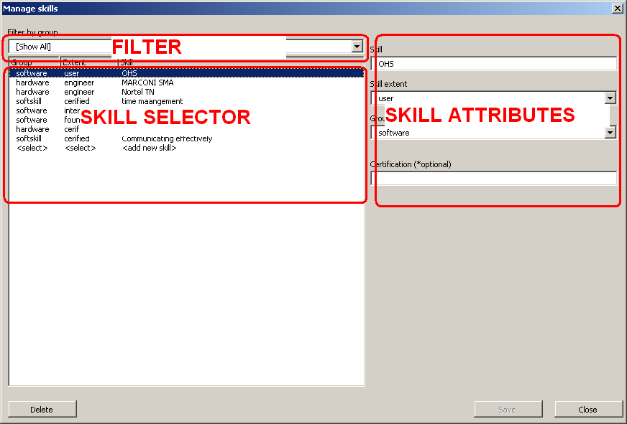

Adding new skill
To add new skill first select last entry in the skill selector with <add new skill> in skills column then edit all required details as per Define skill workflow then press Save button

Editing existing skill
Optional step: use the filter at the top to filter out required group of skills to make finding skill easier.
In the skills selector select the skill you wish to edit.
Amend details for the skill in skill attributes panel as required then press Save button.

Deleting skill
Optional step: use the filter at the top to filter out required group of skills to make finding skill easier.
In the skills selector select the skill you wish to delete.
Press Delete button then confirm to delete.

Manage departments
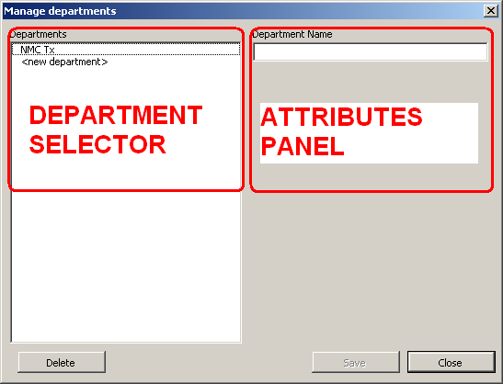

Adding new department
Select last entry in the department selector with <new department> label.
In attributes panel fill in details as per Define department workflow then press Save button

Editing department
Select department you wish to edit in the Department selector panel.
Amend details for the department in the Attributes panel as desired then press Save button

Deleting department
Select department you wish to delete in the Department selector panel
Press Delete button then confirm to delete

Manage JDs

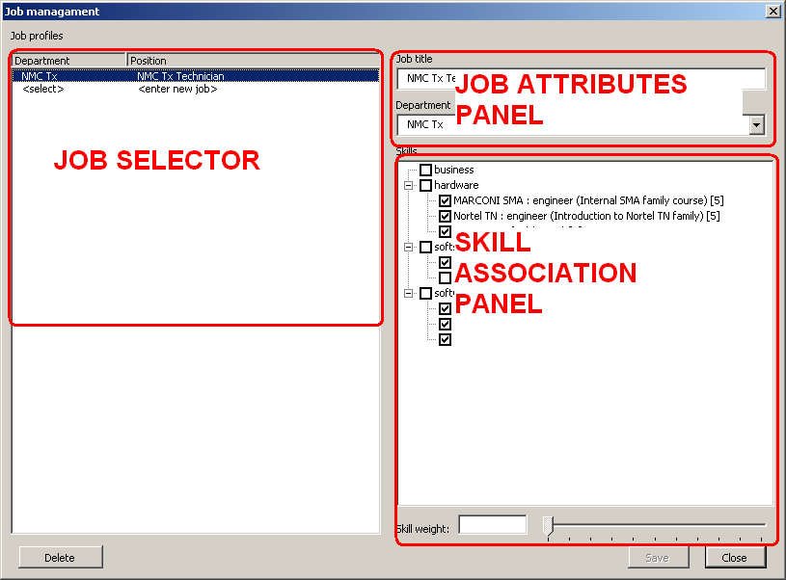

Adding new JD
Select last entry in the Job selector panel with <enter new job> label.
Edit job details in Job attributes panel as required
Associate skills with the job profile by placing check mark by each skill and giving it a weight value in line with Define job description (JD) workflow.

Editing JD
Select job position you wish to edit in Job selector panel.
Amend JD details in Job attributes panel as required.
Amend associated skills and their weights in Skill association panel as required.
Press Save button.

Deleting JD
Select job position you wish to delete in Job selector panel.
Press Delete button then confirm to delete

Manage Staff
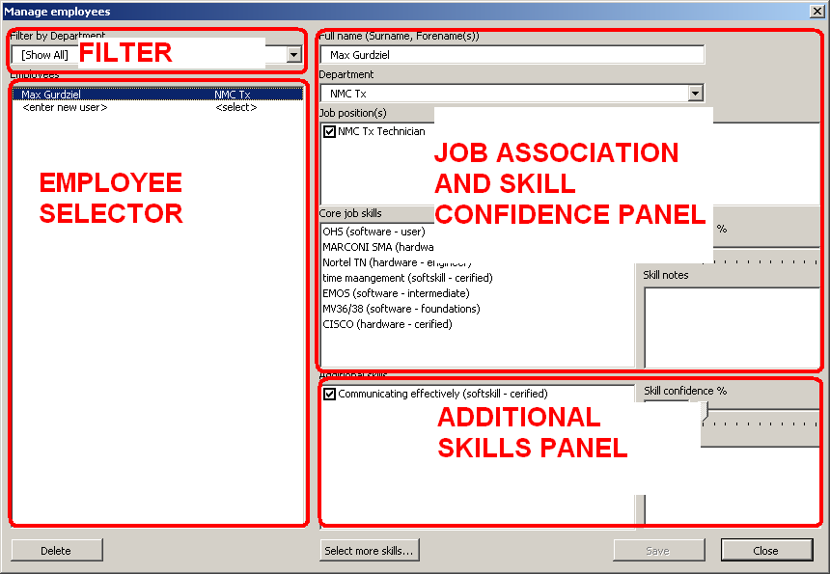

Adding new employee
Select last entry in the Employee selector panel with <enter new user> label.
Amend employee details as per Define employee workflow.
Use Department dropdown to drive available job positions then select one job placement by placing checkmark next to it. The Core job skills (mandatory for the assigned job) will then be added to employee’s record. For each skill change user’s confidence value as required.
Any additional skills can be added to the employee’s profile by pressing Select more skills… button check marking required skill then assigning confidence value greater than 0 to it. If no confidence value is assigned to an additional skill it will be removed from the profile when record is saved.
To delete an additional skill set its confidence value to 0.
Press Save button.

Editing an employee
Optional step: select department to limit employee list to show only staff from that department using Filter panel.
Select an employee record of staff you wish to edit in the Employee selector panel.
Change employee specific details as required. Use Department dropdown to drive available job positions then select one job placement by placing checkmark next to it. The Core job skills (mandatory for the assigned job) will then be added to employee’s record. For each skill change user’s confidence value as required.
Any additional skills can be added to the employee’s profile by pressing Select more skills… button check marking required skill then assigning confidence value greater than 0 to it. If no confidence value is assigned to an additional skill it will be removed from the profile when record is saved.
To delete an additional skill set its confidence value to 0.
If employee job assignment changes all skills will automatically be carried over to the new role. Any skills (core or additional) with confidence above 0 that are not mandatory in the new job will be added to additional employee skills.
Press Save button.

Deleting an employee
Select employee you wish to delete in the Employee selector panel.
Press Delete button then confirm to delete

Support information
Any technical queries should be directed maxoflondon@gmail.com

